

August 26, 2024

«firstname» «lastname»

«address»

«city», «state» «postalcode»

Dear «firstname2»,

On behalf of our Board of Directors, please accept our sincerest appreciation for your generous gift of $«amount» (dated «giftdate»).

Because of caring people like you, we can further our commitment to help those in need. Your continued interest and support gives us the confidence and resources needed to enhance our ability to feed more of those in need.

Should you have any questions about your gift or City Art Museum, please contact me.

Best Regards,

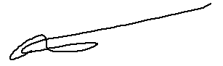

Miles Davis, Executive Director

City Art Museum

*As a 501c3 charity, this letter serves as official acknowledgement of your gift. No goods or services were received with regard to this contribution; therefore, the full amount of your gift is tax deductible. Our Tax Identification Number is 11-1111111. Thank you!*